1-SQL DESCRIBE and EXPLAIN

1-DESCRIBE

🎯 Purpose
# Source: AI Source: Provided by: [Data Path: Persons Table -> ID Column: 1, Name_En Column: Motasem Essam] -> From: [ChatGPT] on [6/11/2026]
Shows the structure of a table — column names, data types, nullability, keys, etc.

✅ Syntax
# Source: AI Source: Provided by: [Data Path: Persons Table -> ID Column: 1, Name_En Column: Motasem Essam] -> From: [ChatGPT] on [6/11/2026]
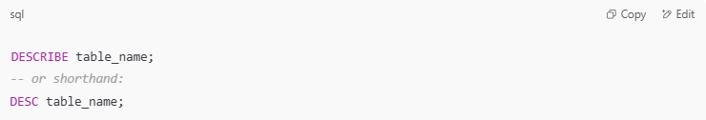
DESCRIBE table_name;
-- or shorthand:
DESC table_name;

🔍 Example
# Source: AI Source: Provided by: [Data Path: Persons Table -> ID Column: 1, Name_En Column: Motasem Essam] -> From: [ChatGPT] on [6/11/2026]
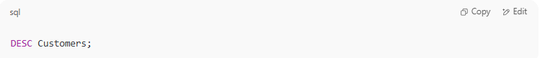
DESC Customers;

Sample Output:
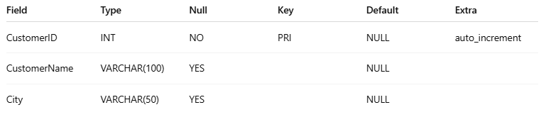
Field | Type | Null | Key | Default | Extra
CustomerID | INT | NO | PRI | NULL | auto_increment
CustomerName | VARCHAR(100) | YES |  | NULL
City | VARCHAR(50) | YES |  | NULL

🧠 Use Cases
# Source: AI Source: Provided by: [Data Path: Persons Table -> ID Column: 1, Name_En Column: Motasem Essam] -> From: [ChatGPT] on [6/11/2026]
- Learn column types before inserting data
- Check if a column allows NULL
- See primary/foreign/indexed keys

Example

prepared commands
# Source: ScreenShot Source: Provided by: [Persons Table -> ID Column: 1, Name_En Column: Motasem Essam] -> Tool: [Automation Table -> ID Column: 16, Name_En Column: Screen Capture] -> From [Operating System: Wampserver64 -> phpmyadmin] on [6/11/2026]
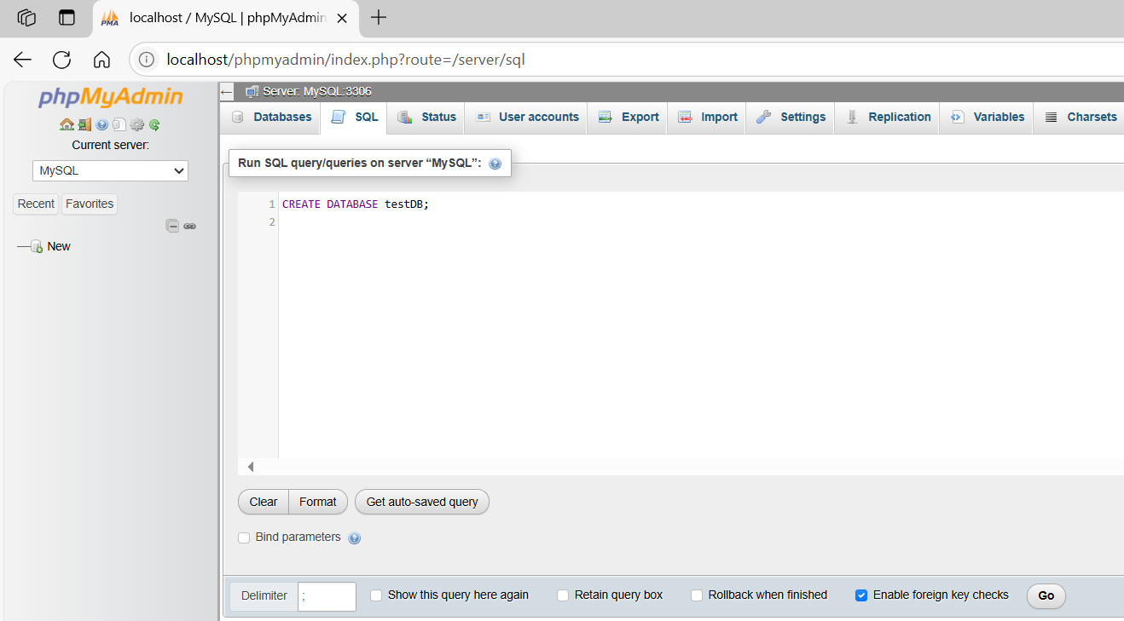
CREATE DATABASE testDB;
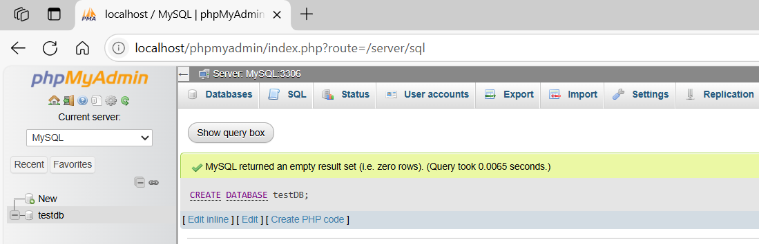
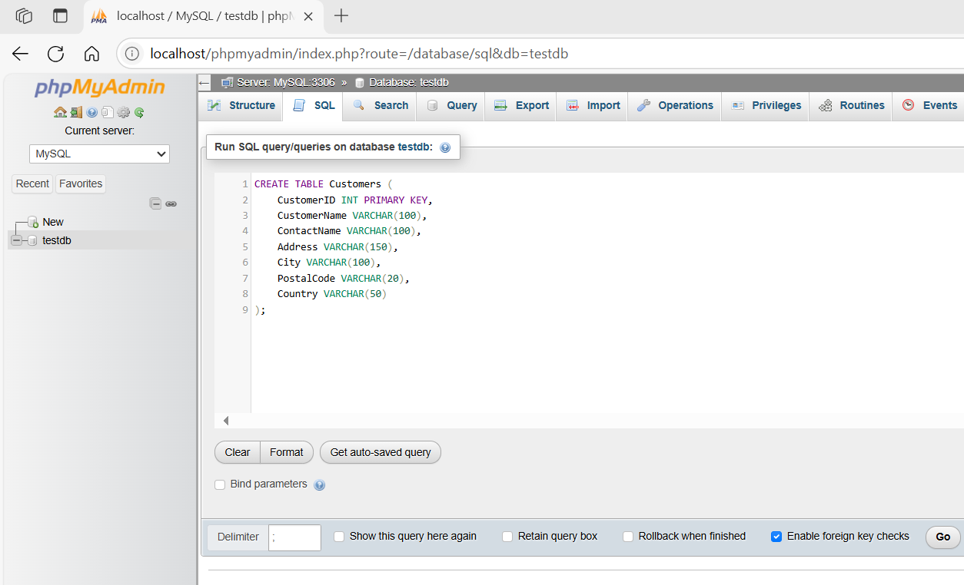
CREATE TABLE Customers (
CustomerID INT PRIMARY KEY,
CustomerName VARCHAR(100),
ContactName VARCHAR(100),
Address VARCHAR(150),
City VARCHAR(100),
PostalCode VARCHAR(20),
Country VARCHAR(50)
);
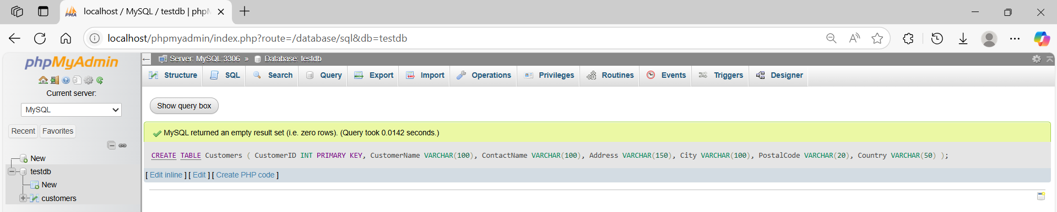
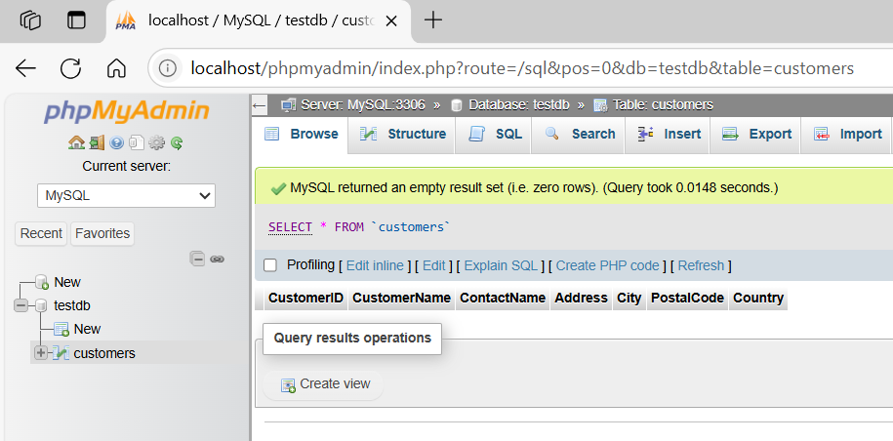
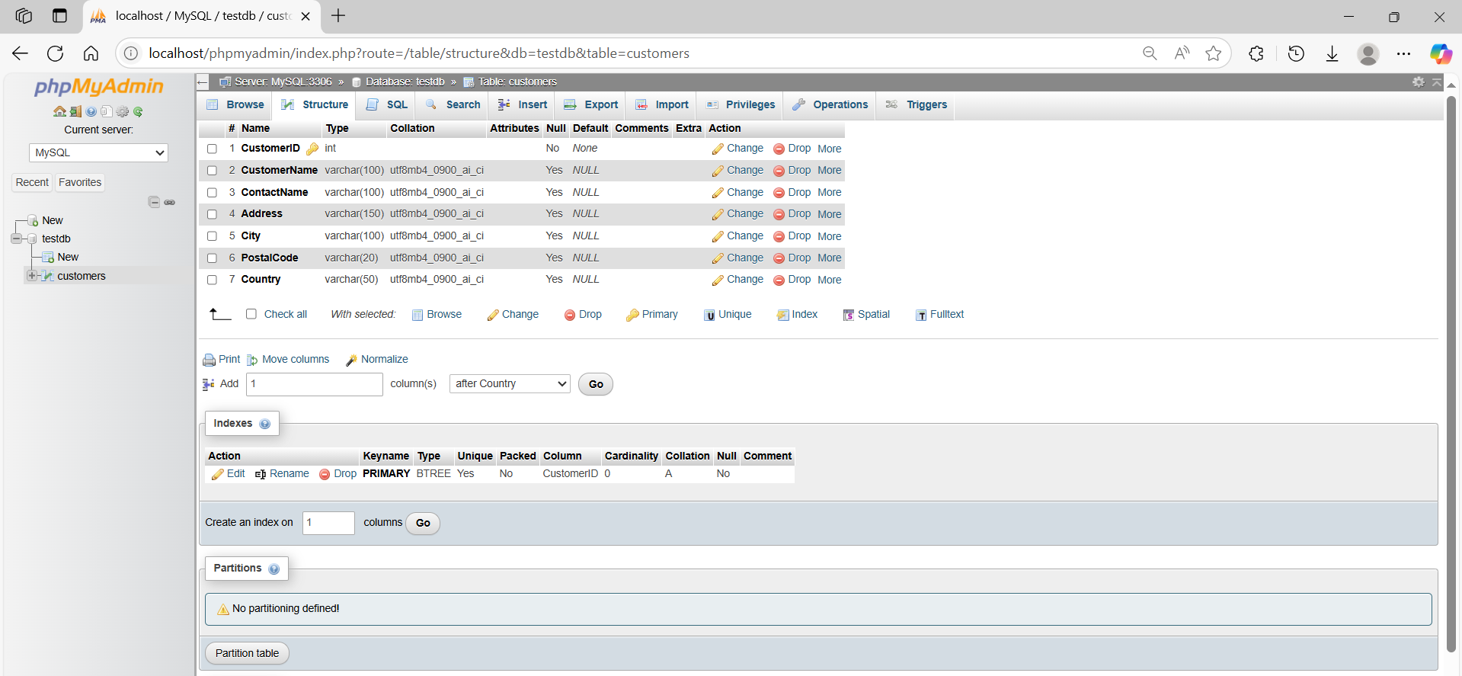

basic command
# Source: ScreenShot Source: Provided by: [Persons Table -> ID Column: 1, Name_En Column: Motasem Essam] -> Tool: [Automation Table -> ID Column: 16, Name_En Column: Screen Capture] -> From [Operating System: Wampserver64 -> phpmyadmin] on [6/11/2026]
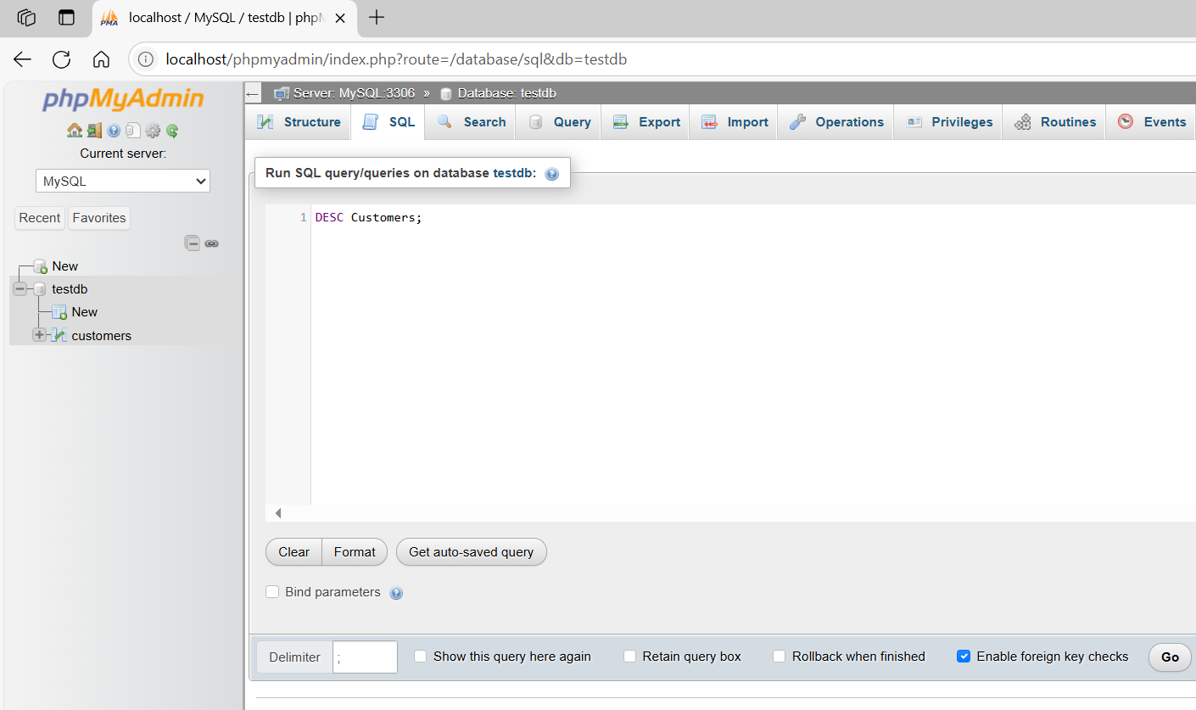
DESC Customers;
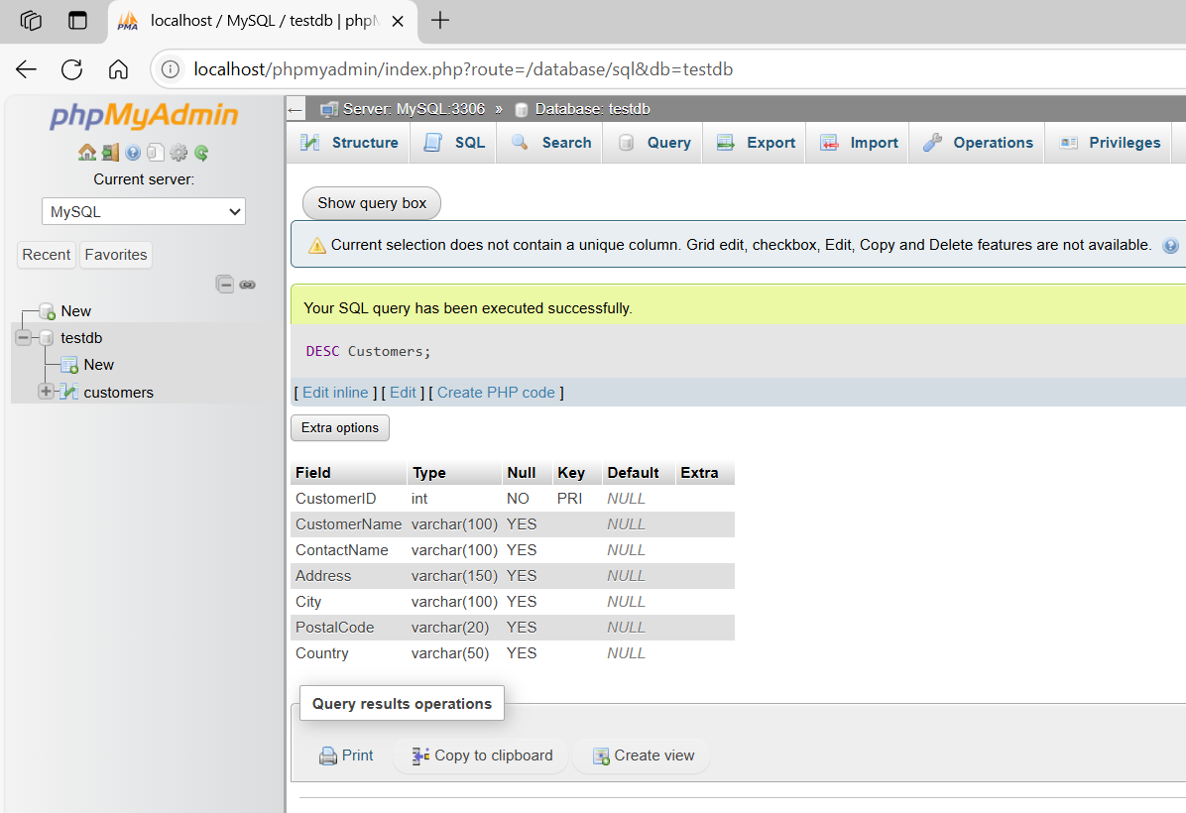

2-EXPLAIN

🎯 Purpose
# Source: AI Source: Provided by: [Data Path: Persons Table -> ID Column: 1, Name_En Column: Motasem Essam] -> From: [ChatGPT] on [6/11/2026]
Analyzes and shows how MySQL executes a SELECT, DELETE, INSERT, or UPDATE query.
Helps identify performance issues and improve query optimization.

✅ Syntax
# Source: AI Source: Provided by: [Data Path: Persons Table -> ID Column: 1, Name_En Column: Motasem Essam] -> From: [ChatGPT] on [6/11/2026]
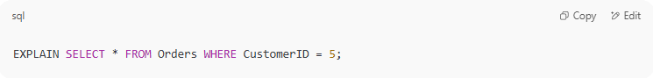
EXPLAIN SELECT * FROM Orders WHERE CustomerID = 5;

🔍 Example Output:
# Source: AI Source: Provided by: [Data Path: Persons Table -> ID Column: 1, Name_En Column: Motasem Essam] -> From: [ChatGPT] on [6/11/2026]
id | select_type | table | type | possible_keys | key | rows | Extra
1 | SIMPLE | Orders | ref | customer_idx | customer_idx | 5 | Using where

🧠 Key Columns
# Source: AI Source: Provided by: [Data Path: Persons Table -> ID Column: 1, Name_En Column: Motasem Essam] -> From: [ChatGPT] on [6/11/2026]
- table – which table is being accessed
- type – join type (ref, ALL, const, etc.) — lower is better
- key – actual index used
- rows – number of rows scanned
- Extra – additional info like Using where, Using index

🧪 Practice
# Source: AI Source: Provided by: [Data Path: Persons Table -> ID Column: 1, Name_En Column: Motasem Essam] -> From: [ChatGPT] on [6/11/2026]
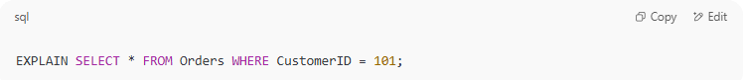
EXPLAIN SELECT * FROM Orders WHERE CustomerID = 101;

🚀 Tips
# Source: AI Source: Provided by: [Data Path: Persons Table -> ID Column: 1, Name_En Column: Motasem Essam] -> From: [ChatGPT] on [6/11/2026]
- DESC is for structure.
- EXPLAIN is for performance tuning.
- Use EXPLAIN ANALYZE (in MySQL 8+) for real-time cost.

Example

prepared commands
# Source: ScreenShot Source: Provided by: [Persons Table -> ID Column: 1, Name_En Column: Motasem Essam] -> Tool: [Automation Table -> ID Column: 16, Name_En Column: Screen Capture] -> From [Operating System: Wampserver64 -> phpmyadmin] on [6/11/2026]

CREATE DATABASE testDB;


CREATE TABLE Customers (
CustomerID INT PRIMARY KEY,
CustomerName VARCHAR(100),
ContactName VARCHAR(100),
Address VARCHAR(150),
City VARCHAR(100),
PostalCode VARCHAR(20),
Country VARCHAR(50)
);



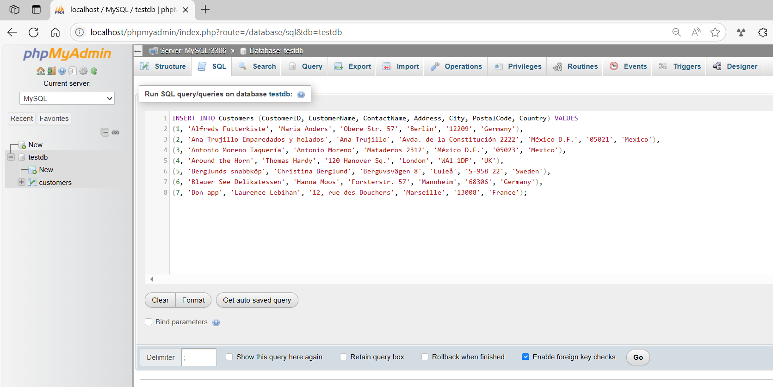
INSERT INTO Customers (CustomerID, CustomerName, ContactName, Address, City, PostalCode, Country) VALUES
(1, 'Alfreds Futterkiste', 'Maria Anders', 'Obere Str. 57', 'Berlin', '12209', 'Germany'),
(2, 'Ana Trujillo Emparedados y helados', 'Ana Trujillo', 'Avda. de la Constitución 2222', 'México D.F.', '05021', 'Mexico'),
(3, 'Antonio Moreno Taquería', 'Antonio Moreno', 'Mataderos 2312', 'México D.F.', '05023', 'Mexico'),
(4, 'Around the Horn', 'Thomas Hardy', '120 Hanover Sq.', 'London', 'WA1 1DP', 'UK'),
(5, 'Berglunds snabbköp', 'Christina Berglund', 'Berguvsvägen 8', 'Luleå', 'S-958 22', 'Sweden'),
(6, 'Blauer See Delikatessen', 'Hanna Moos', 'Forsterstr. 57', 'Mannheim', '68306', 'Germany'),
(7, 'Bon app', 'Laurence Lebihan', '12, rue des Bouchers', 'Marseille', '13008', 'France');
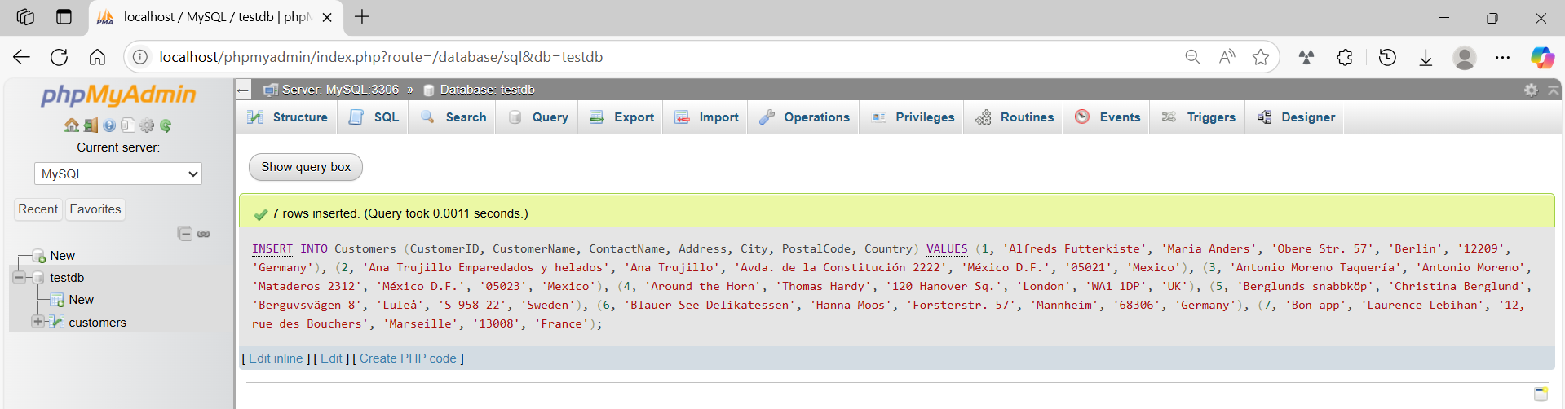
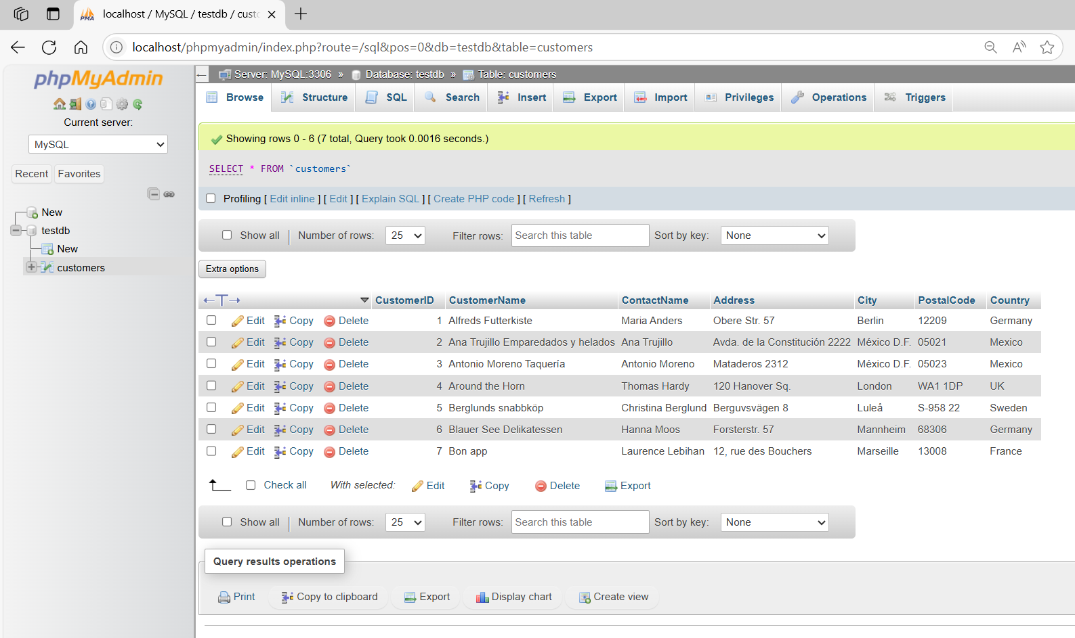

basic command
# Source: ScreenShot Source: Provided by: [Persons Table -> ID Column: 1, Name_En Column: Motasem Essam] -> Tool: [Automation Table -> ID Column: 16, Name_En Column: Screen Capture] -> From [Operating System: Wampserver64 -> phpmyadmin] on [6/11/2026]
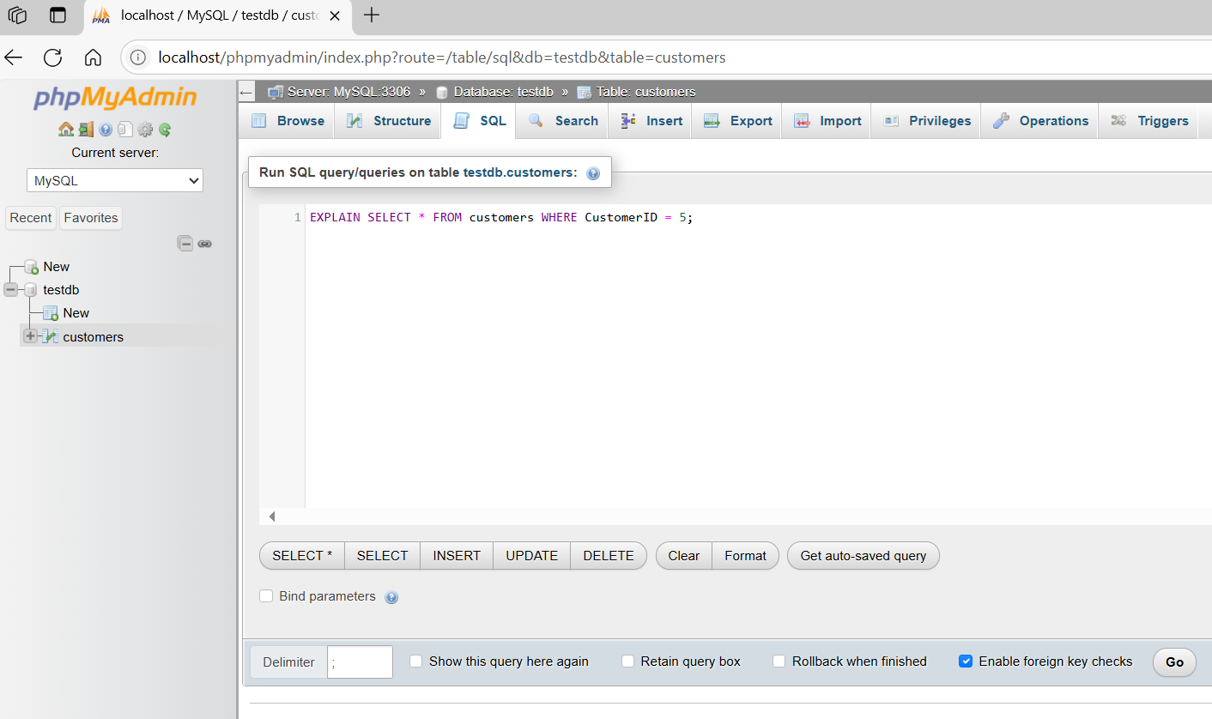EXPLAIN SELECT * FROM customers WHERE CustomerID = 5;
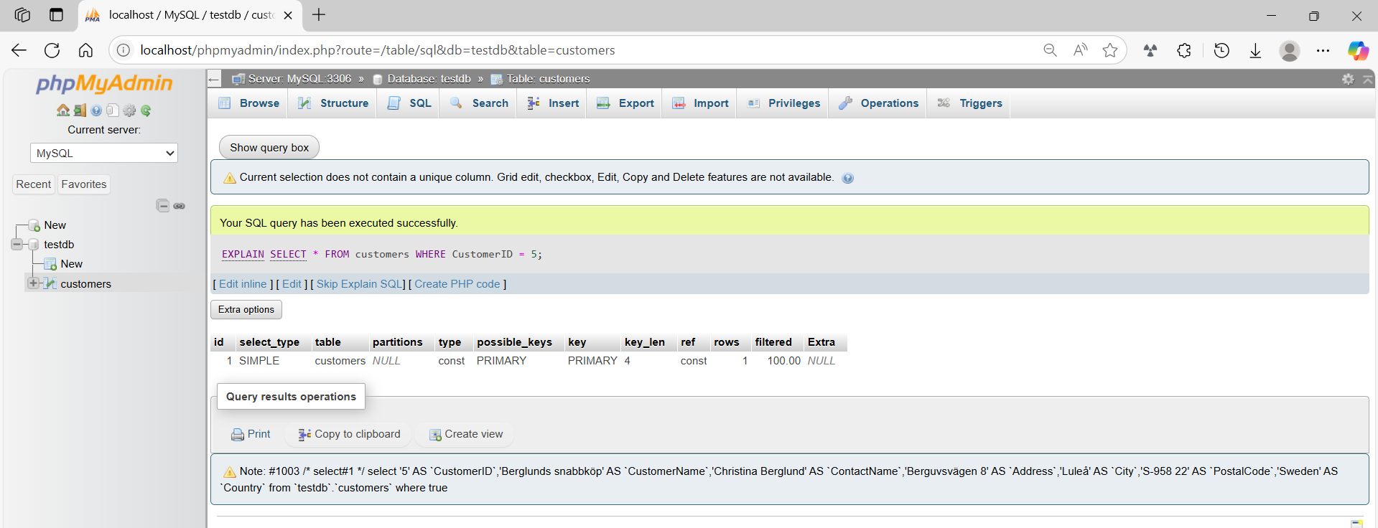

Example output
# Source: AI Source: Provided by: [Data Path: Persons Table -> ID Column: 1, Name_En Column: Motasem Essam] -> From: [ChatGPT] on [6/11/2026]
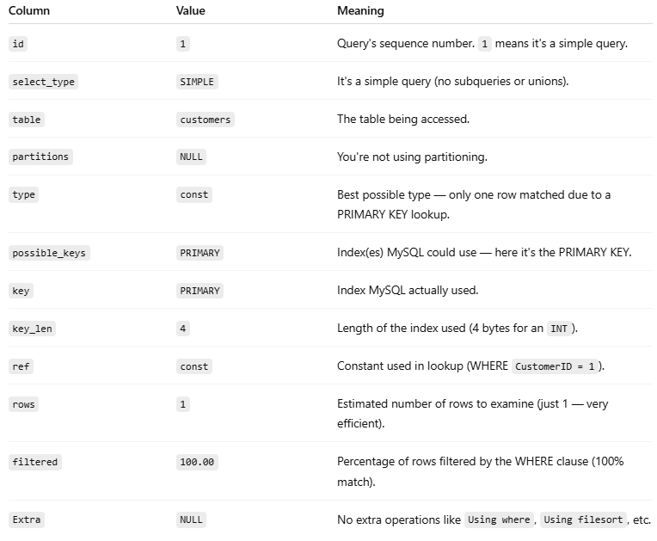
This output comes from running an EXPLAIN or DESCRIBE on a SQL SELECT query in MySQL. It shows how MySQL plans to execute the query—called the query execution plan.
Here’s what each column means in your output:
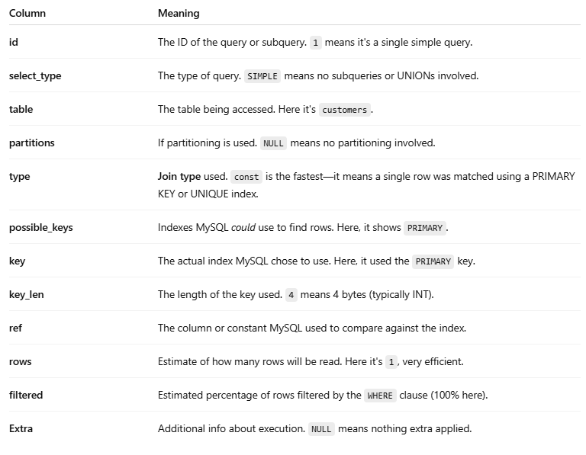
Column | Meaning
id | The ID of the query or subquery. 1 means it's a single simple query.
select_type | The type of query. SIMPLE means no subqueries or UNIONs involved.
table | The table being accessed. Here it's customers.
partitions | If partitioning is used. NULL means no partitioning involved.
type | Join type used. const is the fastest—it means a single row was matched using a PRIMARY KEY or UNIQUE index.
possible_keys | Indexes MySQL could use to find rows. Here, it shows PRIMARY.
key | The actual index MySQL chose to use. Here, it used the PRIMARY key.
key_len | The length of the key used. 4 means 4 bytes (typically INT).
ref | The column or constant MySQL used to compare against the index.
rows | Estimate of how many rows will be read. Here it's 1, very efficient.
filtered | Estimated percentage of rows filtered by the WHERE clause (100% here).
Extra | Additional info about execution. NULL means nothing extra applied.

In Summary:
This means:
MySQL used the PRIMARY key to quickly find a single row from the customers table (because of a condition like WHERE CustomerID = 1), and it expects the result to be returned very efficiently.
Let me know if you want a breakdown of a slower query (like using ALL, range, or index join types) for comparison.

what is query execution plan

🔍 What is a Query Execution Plan in SQL?
# Source: AI Source: Provided by: [Data Path: Persons Table -> ID Column: 1, Name_En Column: Motasem Essam] -> From: [ChatGPT] on [6/11/2026]
A Query Execution Plan (often called Execution Plan or Query Plan) is a roadmap that your database engine (like MySQL, PostgreSQL, SQL Server, etc.) uses to determine how to execute a SQL query most efficiently.
Think of it like Google Maps:
- You ask, “How do I get from point A to point B?”
- It gives you the best route — fast, efficient, possibly avoiding traffic.

Likewise:
- You ask SQL: “Get me these rows.”
- The SQL engine figures out the most efficient path (scan, index, join method, etc.).

🧠 Why Is It Important?
# Source: AI Source: Provided by: [Data Path: Persons Table -> ID Column: 1, Name_En Column: Motasem Essam] -> From: [ChatGPT] on [6/11/2026]
It helps you:
- Understand performance issues.
- Spot inefficient queries (e.g., full table scans when indexes should be used).
- Tune and optimize queries for faster performance.

🛠 How to See It?

✅ In MySQL:
# Source: AI Source: Provided by: [Data Path: Persons Table -> ID Column: 1, Name_En Column: Motasem Essam] -> From: [ChatGPT] on [6/11/2026]
Use EXPLAIN before a SELECT query:
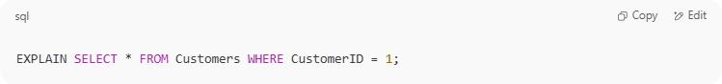
EXPLAIN SELECT * FROM Customers WHERE CustomerID = 1;

✅ In PostgreSQL:
# Source: AI Source: Provided by: [Data Path: Persons Table -> ID Column: 1, Name_En Column: Motasem Essam] -> From: [ChatGPT] on [6/11/2026]
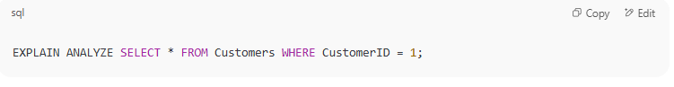
EXPLAIN ANALYZE SELECT * FROM Customers WHERE CustomerID = 1;

📊 What’s in an Execution Plan?
# Source: AI Source: Provided by: [Data Path: Persons Table -> ID Column: 1, Name_En Column: Motasem Essam] -> From: [ChatGPT] on [6/11/2026]
Common components:
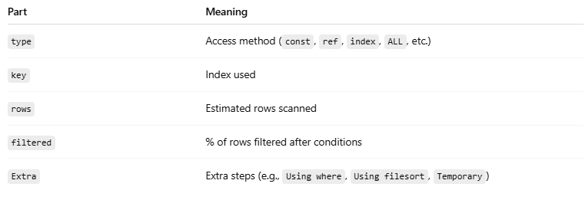
Part | Meaning
type | Access method (const, ref, index, ALL, etc.)
key | Index used
rows | Estimated rows scanned
filtered | % of rows filtered after conditions
Extra | Extra steps (e.g., Using where, Using filesort, Temporary)

Query Execution Plan components
# Source: AI Source: Provided by: [Data Path: Persons Table -> ID Column: 1, Name_En Column: Motasem Essam] -> From: [ChatGPT] on [6/11/2026]
Here’s a detailed breakdown of each component you’ll find in a MySQL EXPLAIN query execution plan, with full explanations and examples for each. This helps you understand how the database processes your SQL under the hood.

🔍 EXPLAIN Components — Detailed Description

✅ id
# Source: AI Source: Provided by: [Data Path: Persons Table -> ID Column: 1, Name_En Column: Motasem Essam] -> From: [ChatGPT] on [6/11/2026]

- Definition: The sequence number of the SELECT in the query.
- Usage: Higher IDs execute first (if nested).
- Values:
  - 1: A simple SELECT.
  - 2, 3, …: Used when subqueries are present.
Example:
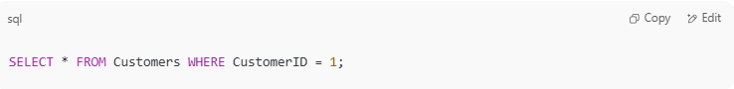
SELECT * FROM Customers WHERE CustomerID = 1;

Output:
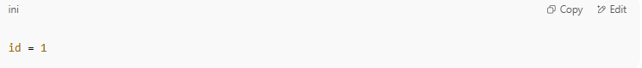
id = 1

✅ select_type
# Source: AI Source: Provided by: [Data Path: Persons Table -> ID Column: 1, Name_En Column: Motasem Essam] -> From: [ChatGPT] on [6/11/2026]
- Definition: Type of SELECT being performed.
- Common values:

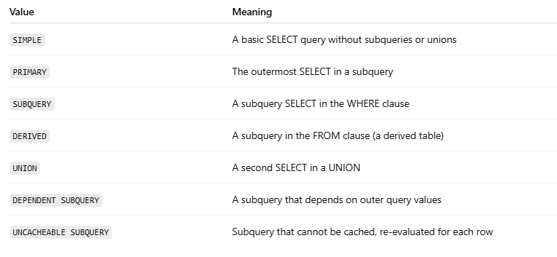
Value | Meaning
SIMPLE | A basic SELECT query without subqueries or unions
PRIMARY | The outermost SELECT in a subquery
SUBQUERY | A subquery SELECT in the WHERE clause
DERIVED | A subquery in the FROM clause (a derived table)
UNION | A second SELECT in a UNION
DEPENDENT SUBQUERY | A subquery that depends on outer query values
UNCACHEABLE SUBQUERY | Subquery that cannot be cached, re-evaluated for each row

Examples
Absolutely! Here's a breakdown of each select_type value in MySQL’s EXPLAIN plan, along with a clear example query for each one. This will help you understand how and when each type appears.
✅ select_type Values with Real Examples

1. SIMPLE
# Source: AI Source: Provided by: [Data Path: Persons Table -> ID Column: 1, Name_En Column: Motasem Essam] -> From: [ChatGPT] on [6/11/2026]
- Definition: A basic SELECT without subqueries or unions.
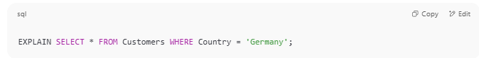
EXPLAIN SELECT * FROM Customers WHERE Country = 'Germany';

🡺 select_type: SIMPLE
➡️ Because it's a standalone SELECT.

2. PRIMARY
# Source: AI Source: Provided by: [Data Path: Persons Table -> ID Column: 1, Name_En Column: Motasem Essam] -> From: [ChatGPT] on [6/11/2026]
- Definition: The outermost query in a subquery structure.
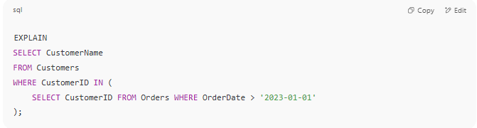
EXPLAIN
SELECT CustomerName
FROM Customers
WHERE CustomerID IN (
SELECT CustomerID FROM Orders WHERE OrderDate > '2023-01-01'
);

🡺 select_type:
- Outer query: PRIMARY
- Subquery: SUBQUERY

3. SUBQUERY
# Source: AI Source: Provided by: [Data Path: Persons Table -> ID Column: 1, Name_En Column: Motasem Essam] -> From: [ChatGPT] on [6/11/2026]
- Definition: A subquery in the WHERE or SELECT clause.
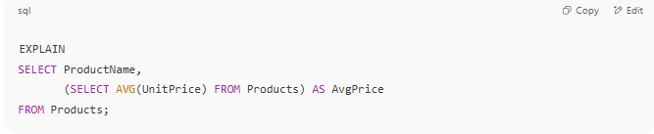
EXPLAIN
SELECT ProductName,
(SELECT AVG(UnitPrice) FROM Products) AS AvgPrice
FROM Products;

🡺 select_type:
- Outer query: PRIMARY
- Subquery: SUBQUERY

4. DERIVED
# Source: AI Source: Provided by: [Data Path: Persons Table -> ID Column: 1, Name_En Column: Motasem Essam] -> From: [ChatGPT] on [6/11/2026]
- Definition: A subquery in the FROM clause, also called a derived table.
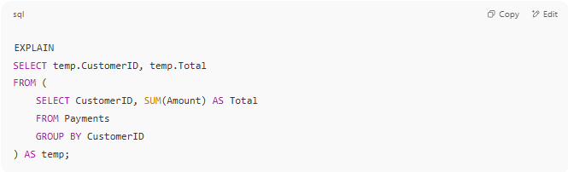
EXPLAIN
SELECT temp.CustomerID, temp.Total
FROM (
SELECT CustomerID, SUM(Amount) AS Total
FROM Payments
GROUP BY CustomerID
) AS temp;

🡺 select_type: DERIVED
➡️ The subquery (temp) is treated as a temporary table.

5. UNION
# Source: AI Source: Provided by: [Data Path: Persons Table -> ID Column: 1, Name_En Column: Motasem Essam] -> From: [ChatGPT] on [6/11/2026]
- Definition: The second and later queries in a UNION.
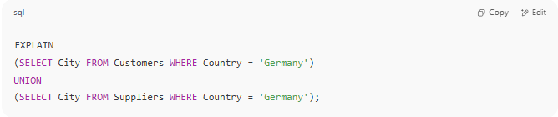
EXPLAIN
(SELECT City FROM Customers WHERE Country = 'Germany')
UNION
(SELECT City FROM Suppliers WHERE Country = 'Germany');

🡺 select_type:
- First part: PRIMARY
- Second part: UNION

6. UNION RESULT
# Source: AI Source: Provided by: [Data Path: Persons Table -> ID Column: 1, Name_En Column: Motasem Essam] -> From: [ChatGPT] on [6/11/2026]
- Definition: The final result set from a UNION query.
This appears only when you EXPLAIN a derived table built using a UNION.

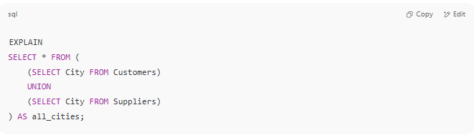
EXPLAIN
SELECT * FROM (
(SELECT City FROM Customers)
UNION
(SELECT City FROM Suppliers)
) AS all_cities;

🡺 select_type: UNION, UNION, UNION RESULT

7. DEPENDENT SUBQUERY
# Source: AI Source: Provided by: [Data Path: Persons Table -> ID Column: 1, Name_En Column: Motasem Essam] -> From: [ChatGPT] on [6/11/2026]
- Definition: A subquery that depends on data from the outer query — it's re-evaluated for every row of the outer query.
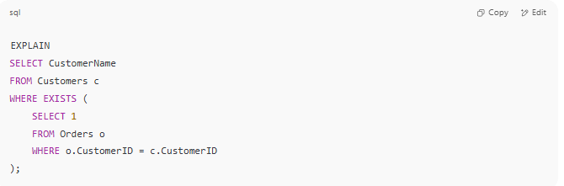
EXPLAIN
SELECT CustomerName
FROM Customers c
WHERE EXISTS (
SELECT 1
FROM Orders o
WHERE o.CustomerID = c.CustomerID
);

🡺 select_type:
- Outer: PRIMARY
- Inner: DEPENDENT SUBQUERY

8. DEPENDENT UNION
# Source: AI Source: Provided by: [Data Path: Persons Table -> ID Column: 1, Name_En Column: Motasem Essam] -> From: [ChatGPT] on [6/11/2026]
- Definition: Like UNION, but the UNION part depends on the outer query.
Rare but can happen in UNIONs inside dependent subqueries.

9. UNCACHEABLE SUBQUERY
# Source: AI Source: Provided by: [Data Path: Persons Table -> ID Column: 1, Name_En Column: Motasem Essam] -> From: [ChatGPT] on [6/11/2026]
- Definition: A subquery whose result can’t be cached, often due to NOW(), RAND(), or use of user-defined variables.
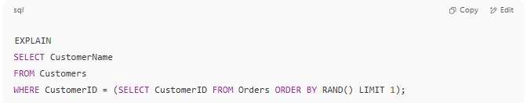
EXPLAIN
SELECT CustomerName
FROM Customers
WHERE CustomerID = (SELECT CustomerID FROM Orders ORDER BY RAND() LIMIT 1);

🡺 select_type: UNCACHEABLE SUBQUERY

📌 Summary Table
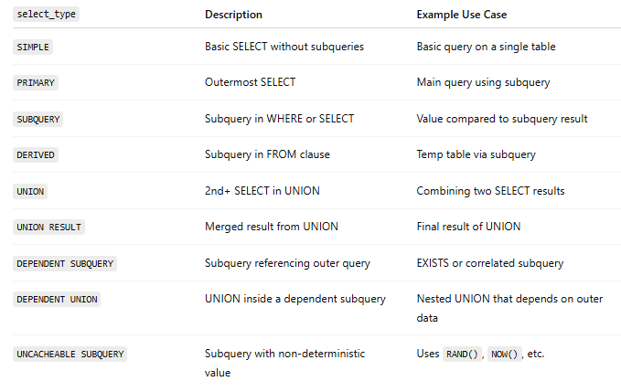
select_type | Description | Example Use Case
SIMPLE | Basic SELECT without subqueries | Basic query on a single table
PRIMARY | Outermost SELECT | Main query using subquery
SUBQUERY | Subquery in WHERE or SELECT | Value compared to subquery result
DERIVED | Subquery in FROM clause | Temp table via subquery
UNION | 2nd+ SELECT in UNION | Combining two SELECT results
UNION RESULT | Merged result from UNION | Final result of UNION
DEPENDENT SUBQUERY | Subquery referencing outer query | EXISTS or correlated subquery
DEPENDENT UNION | UNION inside a dependent subquery | Nested UNION that depends on outer data
UNCACHEABLE SUBQUERY | Subquery with non-deterministic value | Uses RAND(), NOW(), etc.

Would you like to try building queries for each type interactively?

✅ table
# Source: AI Source: Provided by: [Data Path: Persons Table -> ID Column: 1, Name_En Column: Motasem Essam] -> From: [ChatGPT] on [6/11/2026]
- Definition: The name of the table used in this step of the plan.
- Values: Can be the actual table name or an alias.

✅ partitions
# Source: AI Source: Provided by: [Data Path: Persons Table -> ID Column: 1, Name_En Column: Motasem Essam] -> From: [ChatGPT] on [6/11/2026]
- Definition: Lists the partitions the optimizer considers.
- Only shown if the table is partitioned.
- NULL = no partitions.

✅ type (🔑 very important for performance)
# Source: AI Source: Provided by: [Data Path: Persons Table -> ID Column: 1, Name_En Column: Motasem Essam] -> From: [ChatGPT] on [6/11/2026]
- Definition: The join type or access method.
- Ordered from best to worst:
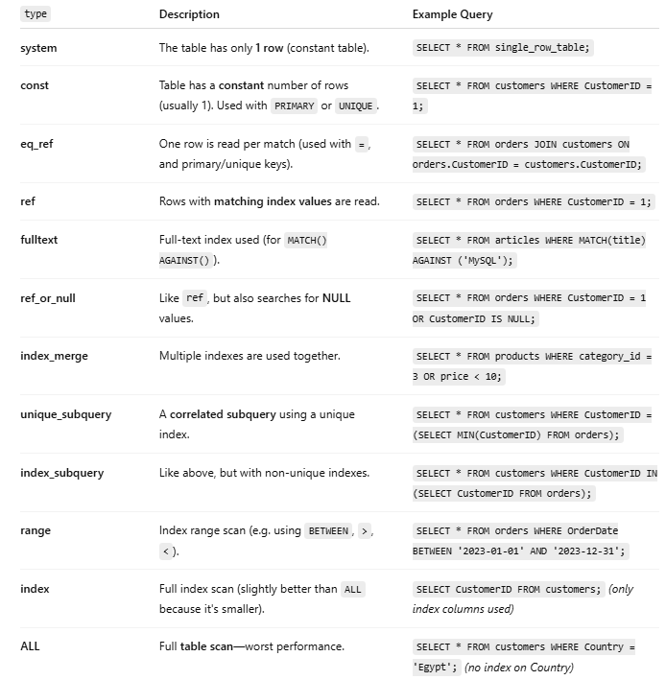

type | Description | Example Query
system | The table has only 1 row (constant table). | SELECT * FROM single_row_table;
const | Table has a constant number of rows (usually 1). Used with PRIMARY or UNIQUE. | SELECT * FROM customers WHERE CustomerID = 1;
eq_ref | One row is read per match (used with =, and primary/unique keys). | SELECT * FROM orders JOIN customers ON orders.CustomerID = customers.CustomerID;
ref | Rows with matching index values are read. | SELECT * FROM orders WHERE CustomerID = 1;
fulltext | Full-text index used (for MATCH() AGAINST()). | SELECT * FROM articles WHERE MATCH(title) AGAINST ('MySQL');
ref_or_null | Like ref, but also searches for NULL values. | SELECT * FROM orders WHERE CustomerID = 1 OR CustomerID IS NULL;
index_merge | Multiple indexes are used together. | SELECT * FROM products WHERE category_id = 3 OR price < 10;
unique_subquery | A correlated subquery using a unique index. | SELECT * FROM customers WHERE CustomerID = (SELECT MIN(CustomerID) FROM orders);
index_subquery | Like above, but with non-unique indexes. | SELECT * FROM customers WHERE CustomerID IN (SELECT CustomerID FROM orders);
range | Index range scan (e.g. using BETWEEN, >, <). | SELECT * FROM orders WHERE OrderDate BETWEEN '2023-01-01' AND '2023-12-31';
index | Full index scan (slightly better than ALL because it's smaller). | SELECT CustomerID FROM customers; (only index columns used)
ALL | Full table scan—worst performance. | SELECT * FROM customers WHERE Country = 'Egypt'; (no index on Country)

🔎 Example:
If type = const, it means only one row was found via index — very fast.

✅ possible_keys
# Source: AI Source: Provided by: [Data Path: Persons Table -> ID Column: 1, Name_En Column: Motasem Essam] -> From: [ChatGPT] on [6/11/2026]
- Definition: Which indexes could be used to find the rows.
- If NULL → no usable index.

✅ key
# Source: AI Source: Provided by: [Data Path: Persons Table -> ID Column: 1, Name_En Column: Motasem Essam] -> From: [ChatGPT] on [6/11/2026]
- Definition: The actual index MySQL chose.
- NULL = no index used (usually a problem!).

✅ key_len
# Source: AI Source: Provided by: [Data Path: Persons Table -> ID Column: 1, Name_En Column: Motasem Essam] -> From: [ChatGPT] on [6/11/2026]
- Definition: The length (in bytes) of the index used.
- Used to understand how much of the index is used (useful in multi-column indexes).

✅ ref
# Source: AI Source: Provided by: [Data Path: Persons Table -> ID Column: 1, Name_En Column: Motasem Essam] -> From: [ChatGPT] on [6/11/2026]
- Definition: The column or constant used with the key.
- Example:
  - const: value in WHERE clause
  - func: result of a function
  - tablename.columnname: value from a join

✅ rows
# Source: AI Source: Provided by: [Data Path: Persons Table -> ID Column: 1, Name_En Column: Motasem Essam] -> From: [ChatGPT] on [6/11/2026]
- Definition: Estimated number of rows MySQL will examine.
- Not actual rows returned, but estimated rows scanned.

✅ filtered
# Source: AI Source: Provided by: [Data Path: Persons Table -> ID Column: 1, Name_En Column: Motasem Essam] -> From: [ChatGPT] on [6/11/2026]
- Definition: Estimated percentage of rows that will pass the WHERE clause.
- Expressed as a percentage.

✅ Extra
# Source: AI Source: Provided by: [Data Path: Persons Table -> ID Column: 1, Name_En Column: Motasem Essam] -> From: [ChatGPT] on [6/11/2026]
- Definition: Additional details about how the query is executed.
- Common values:
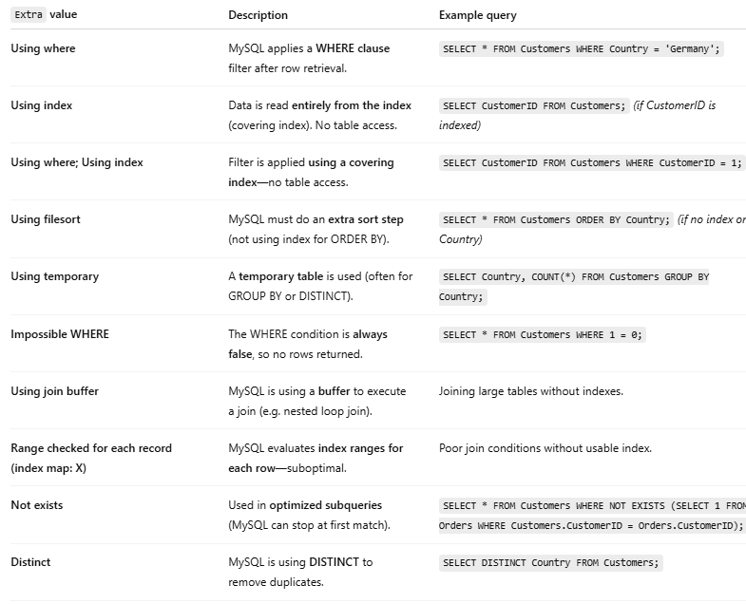
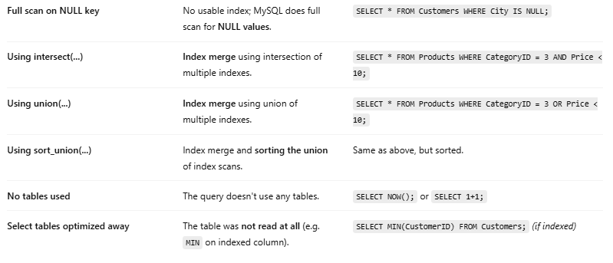

Extra value | Description | Example query
Using where | MySQL applies a WHERE clause filter after row retrieval. | SELECT * FROM Customers WHERE Country = 'Germany';
Using index | Data is read entirely from the index (covering index). No table access. | SELECT CustomerID FROM Customers; (if CustomerID is indexed)
Using where; Using index | Filter is applied using a covering index—no table access. | SELECT CustomerID FROM Customers WHERE CustomerID = 1;
Using filesort | MySQL must do an extra sort step (not using index for ORDER BY). | SELECT * FROM Customers ORDER BY Country; (if no index on Country)
Using temporary | A temporary table is used (often for GROUP BY or DISTINCT). | SELECT Country, COUNT(*) FROM Customers GROUP BY Country;
Impossible WHERE | The WHERE condition is always false, so no rows returned. | SELECT * FROM Customers WHERE 1 = 0;
Using join buffer | MySQL is using a buffer to execute a join (e.g. nested loop join). | Joining large tables without indexes.
Range checked for each record (index map: X) | MySQL evaluates index ranges for each row—suboptimal. | Poor join conditions without usable index.
Not exists | Used in optimized subqueries (MySQL can stop at first match). | SELECT * FROM Customers WHERE NOT EXISTS (SELECT 1 FROM Orders WHERE Customers.CustomerID = Orders.CustomerID);
Distinct | MySQL is using DISTINCT to remove duplicates. | SELECT DISTINCT Country FROM Customers;
Full scan on NULL key | No usable index; MySQL does full scan for NULL values. | SELECT * FROM Customers WHERE City IS NULL;
Using intersect(...) | Index merge using intersection of multiple indexes. | SELECT * FROM Products WHERE CategoryID = 3 AND Price < 10;
Using union(...) | Index merge using union of multiple indexes. | SELECT * FROM Products WHERE CategoryID = 3 OR Price < 10;
Using sort_union(...) | Index merge and sorting the union of index scans. | Same as above, but sorted.
No tables used | The query doesn't use any tables. | SELECT NOW(); or SELECT 1+1;
Select tables optimized away | The table was not read at all (e.g. MIN on indexed column). | SELECT MIN(CustomerID) FROM Customers; (if indexed)

🧪 Sample EXPLAIN Output
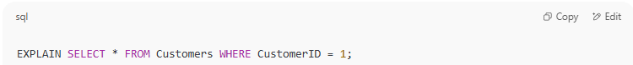
EXPLAIN SELECT * FROM Customers WHERE CustomerID = 1;

id | select_type | table | type | possible_keys | key | key_len | ref | rows | filtered | Extra
1 | SIMPLE | customers | const | PRIMARY | PRIMARY | 4 | const | 1 | 100.00 | Using where
Explanation:
- const → fastest method (uses primary key)
- rows = 1 → expects to read only one row
- Using where → WHERE clause is used

🧠 Summary
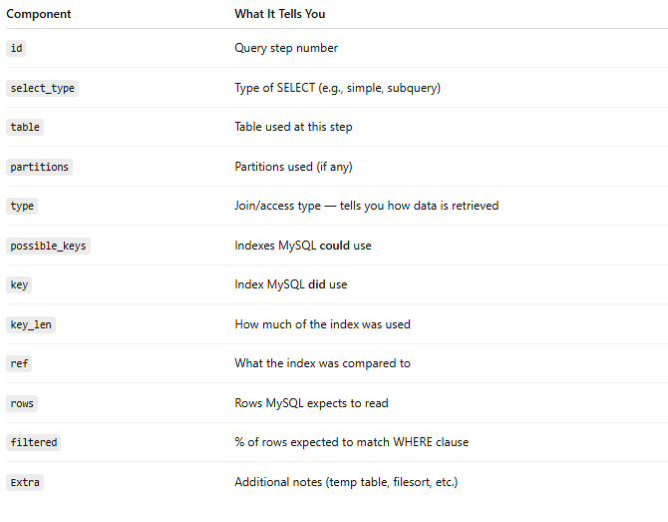
Component | What It Tells You
id | Query step number
select_type | Type of SELECT (e.g., simple, subquery)
table | Table used at this step
partitions | Partitions used (if any)
type | Join/access type — tells you how data is retrieved
possible_keys | Indexes MySQL could use
key | Index MySQL did use
key_len | How much of the index was used
ref | What the index was compared to
rows | Rows MySQL expects to read
filtered | % of rows expected to match WHERE clause
Extra | Additional notes (temp table, filesort, etc.)

Would you like to go further and optimize a slow query using this? Or try comparing two plans (e.g., with vs. without index)?

🧪 Example:
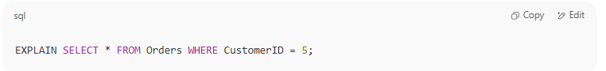

EXPLAIN SELECT * FROM Orders WHERE CustomerID = 5;

Might tell you:
- It's using an index
- Expected to check 1 row
- No temporary table or sorting needed

🧵 Summary:
A Query Execution Plan tells you:
- What the database engine is thinking
- How it's actually running your query
- Whether it's efficient or not
It’s essential for debugging slow queries, especially with large tables.
Let me know if you want to compare plans with and without indexes, or on joins!

